**Implementation date: July 2020**



**Equality and Diversity Policy**

**Review date: July 2021**

**Equality and Diversity Policy**

**Implementation Date: July 2020**

**Review Date: July 2021**

|  |
| --- |
| **SECTION 1: Equality and Diversity Statement** |

The overall objective of the St. Michael’s Community Academy Equality and Diversity Policy is to provide a framework for the school to pursue its equality duties, eliminating unlawful discrimination and harassment; promote equality of opportunity; and promote good relations and positive attitudes between people of diverse backgrounds in all its activities. The principles of this policy apply to all members of the extended school community – pupils, staff, governors, parents and community members. Partners and contractors are also expected to abide by the policy.

|  |
| --- |
| **SECTION 2: Legal Duties** |

This document meets the requirements under the following legislation

* The Equality Act 2010, which introduced the public sector equality duty and protects people from discrimination
* The Equality Act 2010 (Specific Duties) Regulations 2011, which require schools to publish information to demonstrate how they are complying with the public sector equality duty and to publish equality objectives
* This document is also based on Department for Education (DfE) guidance: The Equality Act 2010 and schools.

As a school we welcome our duties under the Equality Act 2010. The general duties are to:

* Eliminate discrimination,
* Advance equality of opportunity
* Foster good relations

We understand the principle of the act and the work needed to ensure that those with protected characteristics are not discriminated against and are given equality of opportunity.

The Equality Act (2010) has identified nine characteristics which must be protected. These are:

* **Age** - Where this is referred to, it refers to a person belonging to a particular age (e.g. 32-year olds) or range of ages (e.g. 18 - 30-year olds). Age discriminations does not apply to the provision of education, but it does to work.
* **Disability** – A physical and/or mental impairment that has what the law calls ‘a substantial and long-term adverse effect on his or her ability to carry out normal day to day activities.
* **Gender Reassignment** - A person (usually with ‘Gender Dysphoria’) who is proposing to undergo, is undergoing or has undergone gender reassignment (the process of changing physiological or other attributes of sex, therefore changing from male to female, or female to male). ‘Intersex’ or ‘Third Sex’ is not covered by the Act but the school will treat Intersex children with the same degree of equality as children with Gender Dysphoria. Children as young as five may begin to show signs of Gender Dysphoria.
* **Marriage and civil partnership –** Marriage is defined as a 'union between a man and a woman'. Same-sex couples can have their relationships legally recognised as 'civil partnerships'. Marriage and civil partnership discrimination does not apply to the provision of education, but it does apply to work.
* **Pregnancy and Maternity –** Pregnancy refers to the condition of being pregnant. Maternity refers to the period of 26 weeks after the birth (including still births), which reflects the period of a woman's Ordinary Maternity Leave entitlement in the employment context. In employment, it also covers (where eligible) the period up to the end of her Additional Maternity Leave.
* **Race** – Race refers to a group of people defined by their colour, nationality, ethnic or national origins. This includes Travellers and Gypsies as well as White British people.
* **Religion and Beliefs** – Religious and philosophical beliefs including lack of belief. Generally, a belief should affect your life choices or the way you live for it to be included in the definition. Religion and belief discrimination does not prevent a school from carrying out collective worship or other curriculum-based activities, but pupils may withdraw from acts of collective worship.
* **Sex** – A man or a woman.
* **Sexual Orientation** – Whether a person's sexual attraction is towards their own sex, the opposite sex or to both sexes. Although children may not identify as gay or lesbian when very young, promotion of sexual orientation equality is as relevant in a primary school environment. For example, a child may have an older sibling or parent who is gay.

School will make a proportionate response to any issues that may arise regarding these nine protected characteristics to ensure compliance with the Equality Act of 2010.

What is unlawful?

* **Direct Discrimination –** Less favourable treatment because of a protected characteristic.
* **Indirect Discrimination -** A provision, criteria or practice that puts a person at a particular disadvantage and is not a proportionate means of achieving a legitimate aim.
* **Harassment -** Conduct which has the purpose or effect of violating dignity or creating an intimidating, hostile, degrading, humiliating or offensive environment. It includes harassment by a third party (e.g. customer or contractor) in the employment context.
* **Victimisation -** Subjecting a person to a detriment because of their involvement with proceedings (a complaint) brought in connection with this Act.

While it is unlawful to discriminate against a pupil with regards to the above-named characteristics, it is also unlawful to discriminate against another person with whom the child is associated e.g. parents.

St. Michael’s aims to take relevant, proportionate and effective response to any issues that may arise with regards to discrimination.

Reasonable Adjustments

Equality law recognises that bringing about equality for disabled people may mean changes bring made or extra support being provided. This is the duty to make ‘reasonable adjustments.’

Schools are required to make ‘reasonable adjustments’ to ensure that, as far as is reasonable, people with a disability have the same access to everything that non-disabled people do. When a duty arises, school will take steps to remove, reduce or prevent the obstacles for a disabled person. School is only required to make adjustments where they have been made aware of the disability.

Public Sector Equality Duty (2011)

The Public Sector Equality Duty (2011) means that public bodies have to consider all individuals when carrying out their day to day work. At St. Michael’s we will:

* Eliminate unlawful discrimination, harassment, victimisation and other conduct that is prohibited by the Equality Act 2010.
* Advance equality of opportunity between people who share a protected characteristic and people who do not share it.
* Foster good relations across all protected characteristics – between people who share a protected characteristic and people who do not share it.

Having ‘Due regard’ to the need to advance equality of opportunity is defined as the need to:

* Remove or minimise disadvantages.
* Take steps to meet different needs
* Encourage participation when it is disproportionately low.

In practice, ‘due regard’ means giving relevant and proportionate consideration to the duty, so decision makers in schools must have due regard when making a decision, developing a policy or taking an action as to whether it may have implications for people because of their protected characteristics.

In order to meet our general duties, listed above, the law requires us to do some specific duties to demonstrate how we meet the general duties. These are to:

* Publish equality information – to demonstrate compliance with the general duty across its functions

**We will not publish any information that can specifically identify any child**

* Prepare and publish equality objectives

To do this we will collect data related to the protected characteristics above and analyse this data to determine our focus for our equality objectives. The data will be assessed across our core provisions as a school. This will include the following functions:

* Admissions
* Attendance
* Attainment
* Exclusions
* Prejudice related incidents

Our objectives will detail how we will ensure equality is applied to the services listed above however where we find evidence that other functions have a significant impact on any particular group we will include work in this area.

We also welcome our duty under the Education and Inspections Act 2006 to promote community cohesion.

We recognise that these duties reflect international human rights standards as expressed in the UN Convention on the Rights of the Child, the UN Convention on the Rights of People with Disabilities, and the Human Rights Act 1998.

In fulfilling our legal obligations, we will:

* Recognise and respect diversity
* Foster positive attitudes and relationships, and a shared sense of belonging
* Observe good equalities practice, including staff recruitment, retention and development
* Aim to reduce and remove existing inequalities and barriers
* Consult and involve widely
* Strive to ensure that society will benefit

|  |
| --- |
| **SECTION 3: Guiding Principles** |

**Vision Statement**

At St. Michael’s Community Academy.

* We endeavour to instil happiness, curiosity and a love of learning through a supportive, challenging and safe environment.
* We aspire to nurture the whole child, instilling confidence and resilience, whilst providing the building blocks for all children to achieve their full potential.
* We aim to shape individuals to become tolerant and empathetic members of the community, to create successful healthy relationships with others and to understand their place in the world around them.

St. Michael’s is a warm and welcoming school where we value the uniqueness of everyone and work with our community to develop the full potential of every child.

In fulfilling the legal obligations cited above, we are guided by the following principles:

These principles have been drawn from a specimen school policy for equalities prepared by the DCSF and we fully endorse and accept them.

**Principle 1:** All learners are of equal value All learners and potential learners are of equal value and benefit equally from school policies, practices and programmes, whatever their ability, background, gender or cultural identity.

**Principle 2:** Relevant differences are recognised. Treating people equally can mean treating them differently. Policies, practices and programmes do not discriminate, but may be differentiated to take account of differences of life experience, outlook and background, and in the kinds of barrier and disadvantage which people may face.

**Principle 3:** We foster positive attitudes, relationships and a shared sense of belonging Policies and programmes promote positive attitudes and interaction, mutual respect and good relations, an absence of harassment or prejudice-related bullying between people of different ability, background, gender or cultural identity.

**Principle 4:** Staff recruitment, retention and development. Policies and procedures benefit all employees and potential employees in recruitment, professional development and promotion. Steps are taken to positively promote equality, especially where there is evidence of inequality.

**Principle 5:** Current inequalities and barriers are addressed and reduced in addition to avoiding or minimising possible negative impacts of policies and programmes, we take opportunities to maximise positive impacts by addressing, reducing and removing inequalities and barriers that already exist between people of different ability, background, gender or cultural identity.

**Principle 6:** Policy development involves widespread consultation and involvement. People affected by a policy or programme are consulted and involved in the design of new policies, and in the review of existing ones. Such consultation is both direct and through representative organisations and is based on principles of transparency and accountability. It involves those who in the past have been excluded or disadvantaged, and who continue to face barriers:

**Principle 7:** Society as a whole benefits. Policies and programmes benefit society as a whole, locally, nationally and internationally, by fostering greater cohesion and greater participation in public life of people of different ability, background, gender or cultural identity.

**Addressing Prejudice Related Incidents**

This school is opposed to all forms of prejudice and we recognise that children and young people who experience any form of prejudice related discrimination may fair less well in the education system. We provide both our pupils and staff with an awareness of the impact of prejudice in order to prevent any incidents. If incidents still occur we address them immediately and report them to the Local Authority using their guidance material.

|  |
| --- |
| **SECTION 4: Responsibility** |

We believe that promoting Equality is the whole school’s responsibility.

| **School Community** | **Responsibility** |
| --- | --- |
| Governing Body | Involving and engaging the whole school community in identifying and understanding equality barriers and in the setting of objectives to address these. |
| Principal | As above including:  Promoting key messages to staff, parents and pupils about equality and what is expected of them and can be expected from the school in carrying out its day to day duties. Ensure that staff have appropriate skills to deliver equality, including pupil awareness. Ensure that all staff are aware of their responsibility to record and report prejudice related incidents. |
| Senior Leadership Team | To support the Principal, as above.  Ensure fair treatment and access to services and opportunities. Ensure that all staff are aware of their responsibility to record and report prejudice related incidents. |
| Teaching Staff | Help in delivering the right outcomes for pupils.  Uphold the commitment made to pupils and parents/carers on how they can be expected to be treated.  Design and deliver an inclusive curriculum  Ensure that you are aware of your responsibility to record and report prejudice related incidents. |
| Non-Teaching Staff | Support the school and the governing body in delivering a fair and equitable service to all stakeholders.  Uphold the commitment made by the Headteacher/principal on how pupils and parents/carers can be expected to be treated.  Support colleagues within the school community.  Ensure that you are aware of your responsibility to record and report prejudice related incidents. |
| Parents | Take an active part in identifying barriers for the school community and in informing the governing body of actions that can be taken to eradicate these.  Take an active role in supporting and challenging the school to achieve the commitment given to the school community in tackling inequality and achieving equality of opportunity for all. |
| Pupils | Supporting the school to achieve the commitment made to tackling inequality.  Uphold the commitment made by the head teacher on how pupils and parents/carers, staff and the wider school community can be expected to be treated. |
| Local Community Members | Take an active part in identifying barriers for the school community and in informing the governing body of actions that can be taken to eradicate these.  Take an active role in supporting and challenging the school to achieve the commitment made to the school community in tackling inequality and achieving equality of opportunity for all. |

|  |
| --- |
| **SECTION 5: Monitoring and Review** |

The principal, David Jobling, is responsible overall for dealing with reports of prejudice-related incidents. Visitors and contractors are responsible for following relevant school policy.

**Staff development:** Staff undertake training and development in relation to equality and cohesion in terms of professional responsibilities as well as statutory requirements as and when appropriate. This may take the format of staff meeting updates or full training sessions when needed. All staff are given equal opportunity to take part in staff training and have access to courses appropriate to their professional development and responsibilities as well as statutory requirements.

**Publication and review:** This Equality Scheme fulfils statutory requirements under the terms of legislation referred to above. As it is a public document, the school governors publish it by making it available on request. The scheme will be kept under regular review for three years.

**How we conduct equality impact assessment**: As a school we carry out rigorous monitoring and analysis of all pupils and their progress each term so that the Principal, SLT, subject leaders and class teachers can use the information to ensure the appropriate progress is made by all pupils regardless of race, disability, socio-economic background, belief or gender. Through analysis we are aware of any groups or individuals who are not making at least expected progress.

|  |
| --- |
| **SECTION 6: Equality Objectives** |

Our equality objective-setting process has involved gathering evidence as follows:

* From the monitoring and analysis of pupil progress in the identified groups.
* From the Monitoring and evaluation evidence file, SEN files, Gifted and talented files, Vulnerable pupil information
* From involving relevant people including pupil and parental surveys.

The evidence was then analysed in order to choose objectives that will: i.

* Promote equality of opportunity for members of identified groups
* Eliminate unlawful discrimination, harassment and victimisation.
* Foster good relations between different groups as identified in Section 2

**Equality objectives**

1. Ensure that children who are entitled to Pupil Premium make expected progress across the curriculum in relation to non-Pupil Premium children.
2. Ensure that the curriculum meets the needs of all children.
3. Ensure that staff and the governing body are aware of current legislation surrounding diversity and equality and understands the school’s responsibility
4. Ensure that vulnerable groups of pupils including those with additional needs make at least expected progress academically, socially and emotionally. They are able to achieve challenging, personalised targets and the gaps in attainment for these pupils are reduced.
5. Ensure to raise attainment of More and Most Able pupils throughout the school and have access to all pupils to engage in extended school provision

We will ensure that the whole school community is aware of the Single Equality Policy and our published equality information and equality objectives by publishing them on our school website

**Complaints**

Complaints with regard to this policy will be dealt with via the school’s complaints procedure, a copy of which is available from the school office, or on the website.

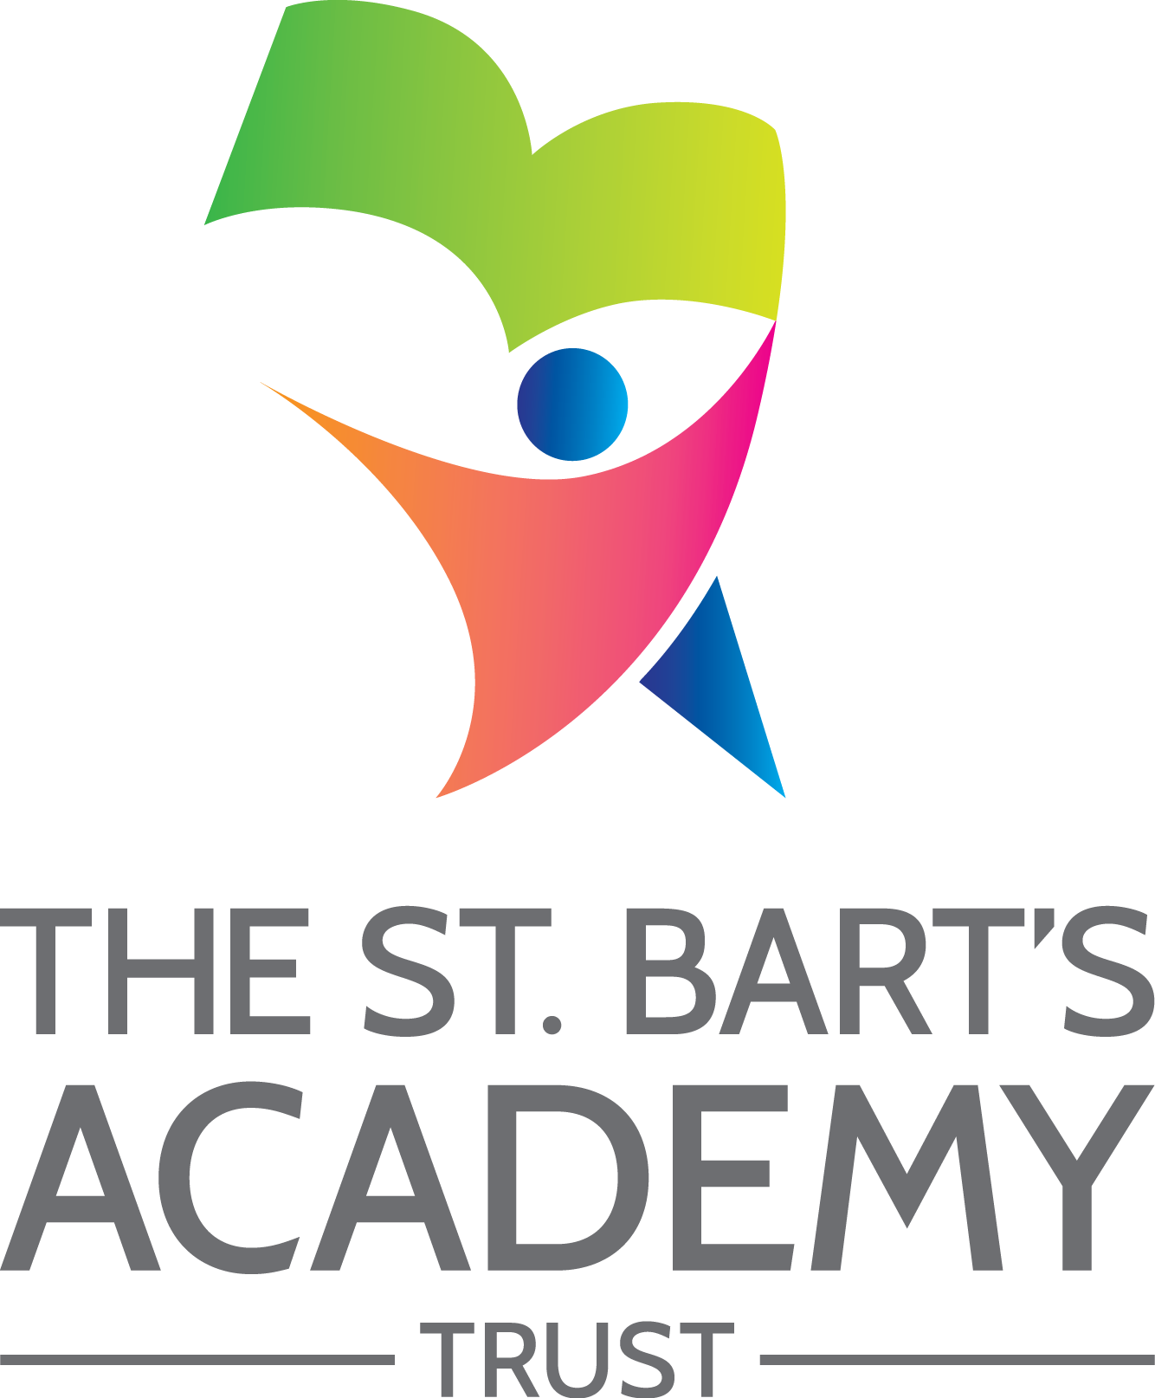

St. Bart’s Multi-Academy Trust

c/o Belgrave St. Bartholomew’s Academy,

Sussex Place, Longton, Stoke-on-Trent, Staffordshire, ST3 4TP

www.XXX.org T: 01782 235524 F: 01782 235525